*Come Sing!*

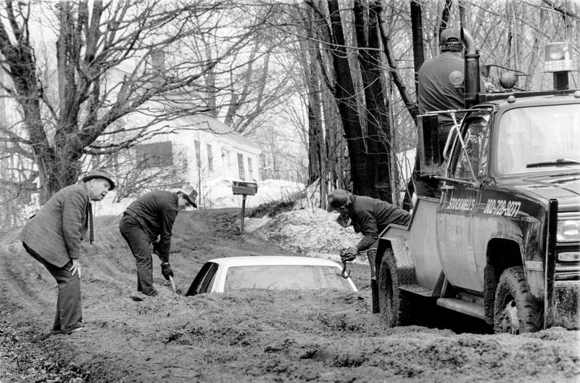

**Saturday, Feb 24th 12:30-2:30**

**Bethany Church, 115 Main St., Montpelier**

**Leader: Rev. Mary Edes**

In these late winter days, what better way to spend two precious hours than singing together just for the fun of it!  Come join in the song! Lift your spirits and celebrate Mud Season! Music will be provided and taught by ear.

Rev. Mary Edes is the founder and director of the Silver Lake Singers, for healing and hospice, and serves as a community minister in various congregations throughout New England. She will be preaching at the Unitarian Church on Sunday morning at 10:00.