## 2020

## Easter Morning in ‘Shut Down’ Puerto Viejo

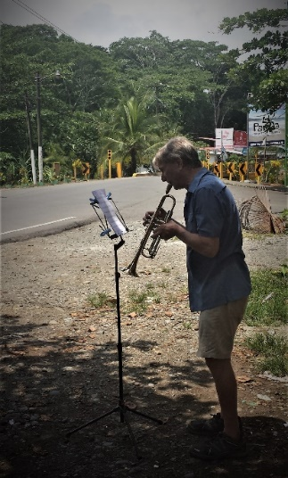

Usually, Semana Santa (Easter Week) is the busiest week in this town as throngs of vacationers stream down from San Jose and other inland cities and towns to enjoy a week at the beach. I would guestimate that the town triples in size overtaxing all the town’s resources. The locals stock up on everything they need before the onslaught begins, then stay at home, and wait for the invasion to be over ten days later. Then the locals come out in organized droves to pick up all the trash on the beaches and in town from the party-goers to reclaim our town. We are glad that the Ticos (Costa Ricans) get to enjoy the beauty of the South Caribbean Coast, and we acknowledge that even though they are guests in our town, we are guests (ex-pats) in their country. Come to think of it, we’re all guests here on planet Earth—Thank you God. But this year is different, and the town was shut down tighter than a drum.

About two weeks ago, as I was nearing the completion of the extensive revisions, additions, and edits of the 3rd Edition of *Sourcing the Life You Love*, my inclinations began to drift toward music again. I usually bring a trumpet down to Costa Rica when I come, but this time I didn’t because I knew my creative energies would be fully engaged in writing. But with COVID-19 shutting down most of the world, I am not free to travel. Well, I love it here, so that does not pose much of a hardship. Also, as a writer, I am in voluntary seclusion most of the time anyway, so isolating is not a hardship. I went online to see if I could find a decent used trumpet that I could play and keep in Costa Rica for the duration and for future visits. No luck, all the trumpets I could find were ‘junk’ affording the player little or no musical satisfaction—pass. Three days later, I see a notification on Facebook that my former trumpet student here of 2-3 years ago has a really fine 47-year-old trumpet for sale in excellent condition. He brought it over to my casita along with his even better trumpet, we played together for a while, I loved the horn and bought it.

I realized that there were still eight days until Easter, and even though I hadn’t played for months, if I was very dedicated, I could probably get enough ‘lip’ back in shape to play some Easter music in our shut down village. All the non-essential businesses have been closed for weeks, including the churches. Curiously, the government sees churches as non-essential, even though this is a country that recognizes Catholicism as the state religion. All the beaches are closed down with miles of yellow police tape. During Easter Week, Motor vehicles are permitted to drive only one day a week as monitored by the last digit of their license plate, and at that, only between 5 A.M. and 5 P.M. I so much wanted to bring a little bit of Easter spirit through music into this ‘ghost town,’ if only to a few who happened by to hear it by chance.

Now I had a trumpet, but no music stand and no music. With the help of my Spanish speaking ex-student, we ordered online a stand and a cleaning kit from a music store in San Jose. I then had to go to the local bank and pay to the music store’s account the cost, including transportation by bus to Puerto Viejo. Remarkably, the package arrived the next afternoon at 4:00 P.M. Now, all I needed was some Easter music. I had a few pieces saved on my computer, but not sufficient for a mini-concert. I have an online account with Virtual Sheet Music and downloaded a few pieces which I had to get printed. But, the copy shop in town is not an ‘essential service’ and was locked down tight. Fortunately, a good friend came to the rescue and printed off all the music I needed at his home.

Typically, I wouldn’t consider performing in public without at least four weeks to toughen up my lip and to exercise all the muscles of my embouchure so they can endure the strenuous workout of performing. It may sound like I’m joking, but I’m not. If you have ever worked out in a gym using weights, at some point, your muscles hit the wall, quiver from exhaustion, and you just can’t get them to respond anymore, they just stop working. The same is true of the embouchure, and you just can’t make your lips do what they are supposed to do. I had short single and double practices each day to try to get everything in shape without overdoing it, and to develop muscle memory so I would depress the right combination of valves to get the desired notes. By Saturday night, I determined that the ‘concert’ was a ‘go’; it might not be perfect, but it would add a cheerful note of Easter spirit to the town. This would be the musical equivalent of “Better to light a candle than to curse the darkness.”

Sunday morning, a friend helped me walk the music paraphernalia into town. Two nearby food markets were blasting commercial music into the street. We politely asked them if they would turn off their music while we made live Easter music, and they gladly agreed. How often do they get a live trumpet concert in their fair town? I chose a street corner near the entrance to the village because that is where the homeless street people hang out, and having a captive audience might be my only audience. This was an unpublicized performance, and it was not certain if anyone would stop to listen. Given how few people were in town, I think we had a fair percentage. The big uncertainty about playing in public was if the police, who were out in force to maintain the shutdown, would close down this mini-concert. I had asked a couple of friends there, if necessary, to have onlookers maintain the prescribed social distancing. But, no police were seen, and the concert was not shut down.

I had just enough lip and embouchure to play with enthusiasm until the last measure of the final piece, *Christ the Lord is Risen Today* when my endurance ran out. Try as I might, I couldn’t play the last triumphant notes. People applauded anyway because they knew I had given it my all. I felt like the pictures of marathon runners crawling on hands and knees to finish the last few yards of the race, but they won’t quit. I play the trumpet because I love it. I tell myself if it gives just one person a moment of Joy, it is worth it. Well, I know it did that because it gave me Joy, and whoever else received Joy, that was all bonus. Much Love to all of you this Easter, where we find creative ways of being together to celebrate the Hope of spirit-raising that Easter brings.