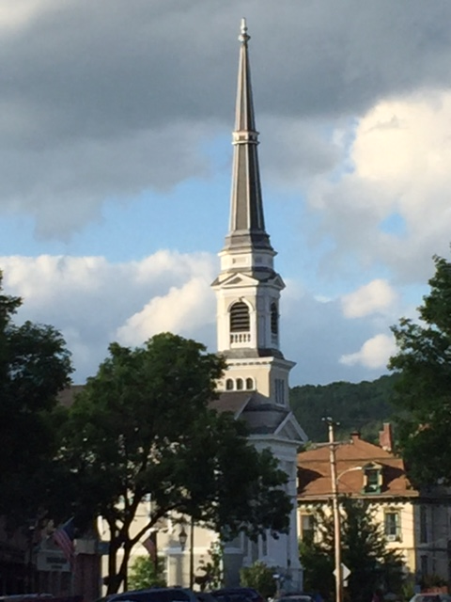

Does our church building serve our mission?

What would it take for UCM to become:
- A net zero energy church?
- A truly accessible building with a real elevator and better traffic flow?
- A refugee sanctuary temporarily housing up to four people?
- A church with easy access to a code compliant, fully functioning kitchen?

The Property Committee is hosting a 90-minute symposium to look at all the above options on April 6th (this Thursday) at 2 PM in the Vestry. Plan to attend. Come share your thoughts. Make a difference!

