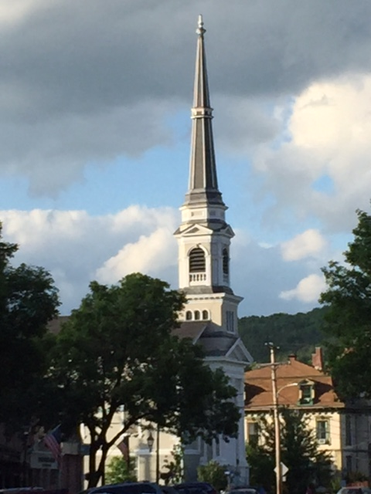

***Does our church building serve our mission?***

***What would it take for UCM to become:***

* A net zero energy church?
* A truly accessible building with a real elevator and better traffic flow?
* A refugee sanctuary temporarily housing up to four people?
* A church with easy access to a code compliant, fully functioning kitchen?

The Property Committee is hosting a 90-minute symposium to look at all the above options on **April 6th** (this Thursday) at **2 PM** in the Vestry. Plan to attend. Come share your thoughts. Make a difference!